
MULTI-TENANT HOUSING MANAGER
Software Development Life Cycle (SDLC) Documentation
Student Name: Geovanni Bonilla
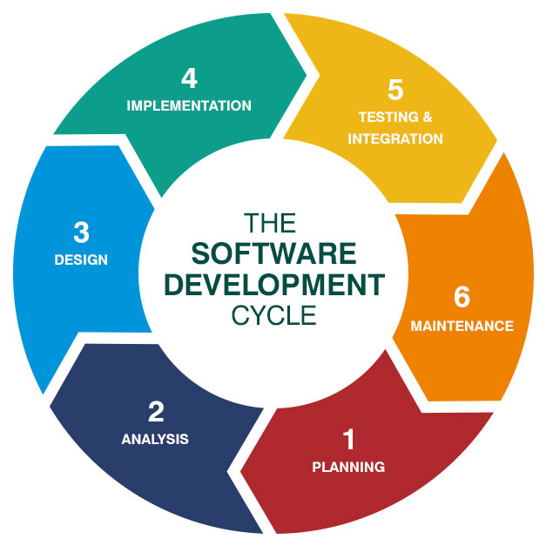
This document explains the Software Development Life Cycle (SDLC) used during the creation of the Multi-Tenant Housing Manager application.

1. Planning
The planning phase focused on identifying the main goals of the application.
The system was designed to help property managers organize tenant information,
track rent and utilities, and manage lease durations.
Main planned features included:
• CRUD operations
• Dynamic search functionality
• Rent visualization charts
• CSV export support
• Dark and light mode themes

2. Analysis
During the analysis phase, system and user requirements were identified.
System Requirements:
• Java JDK 21 or higher
• JavaFX SDK 21
• Visual Studio Code
User Requirements:
• Easy tenant management
• Dynamic searching
• Simple graphical interface
• Visual data representation

3. Design
The design phase focused on software architecture and interface planning.
The application was divided into:
• Model Layer
• Controller Layer
• View Layer
• Utility Layer
Main classes:
• App.java
• MainApp.java
• Tenant.java
• TenantController.java
• FileHandler.java

4. Implementation
During implementation, the application features were developed using Java and JavaFX.
Implemented features:
• Add/Edit/Delete tenants
• Search functionality
• Bar chart visualization
• CSV export support
• Dark/Light mode toggle
• Confirmation dialogs
• Input validation

5. Testing & Integration
The testing phase verified that all system features worked correctly.
Testing included:
• CRUD testing
• Search testing
• Chart testing
• CSV export testing
• Theme switching testing
All major components integrated successfully.

6. Maintenance
The maintenance phase focused on future scalability and improvements.
Future improvements:
• Database integration
• Login system
• Advanced analytics
• Additional charts
• Revenue reports

DIAGRAMS SECTION

UML CLASS DIAGRAM
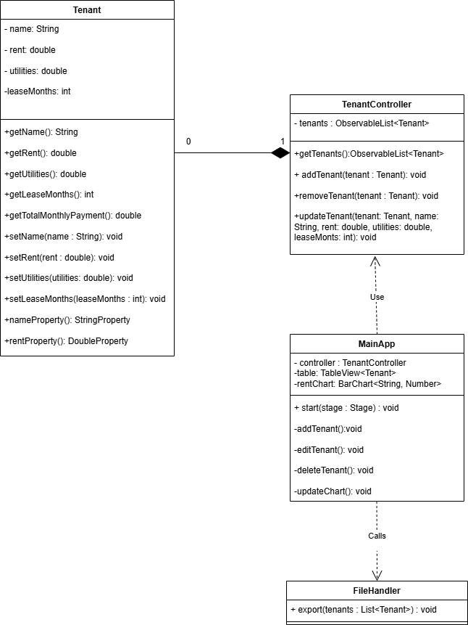

DATABASE SCHEMA
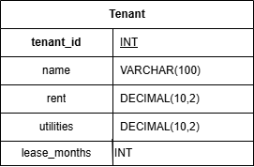

INTERACTION DIAGRAM
